Git Hub Creation

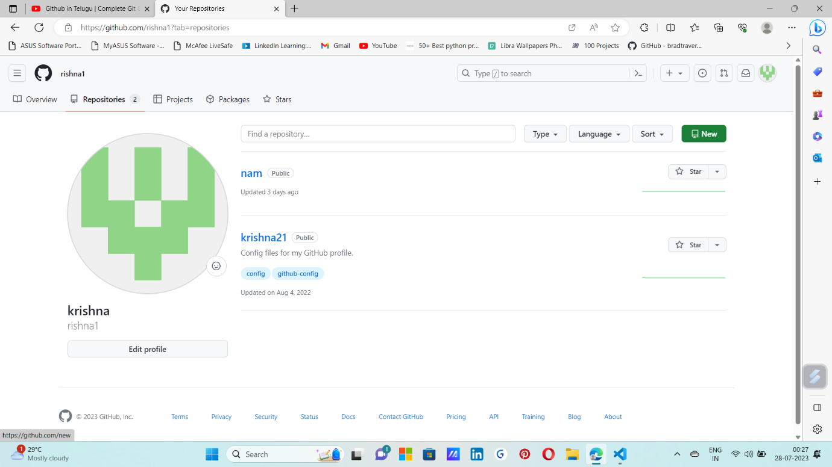

Step 1: open github and click on repositori and click on new

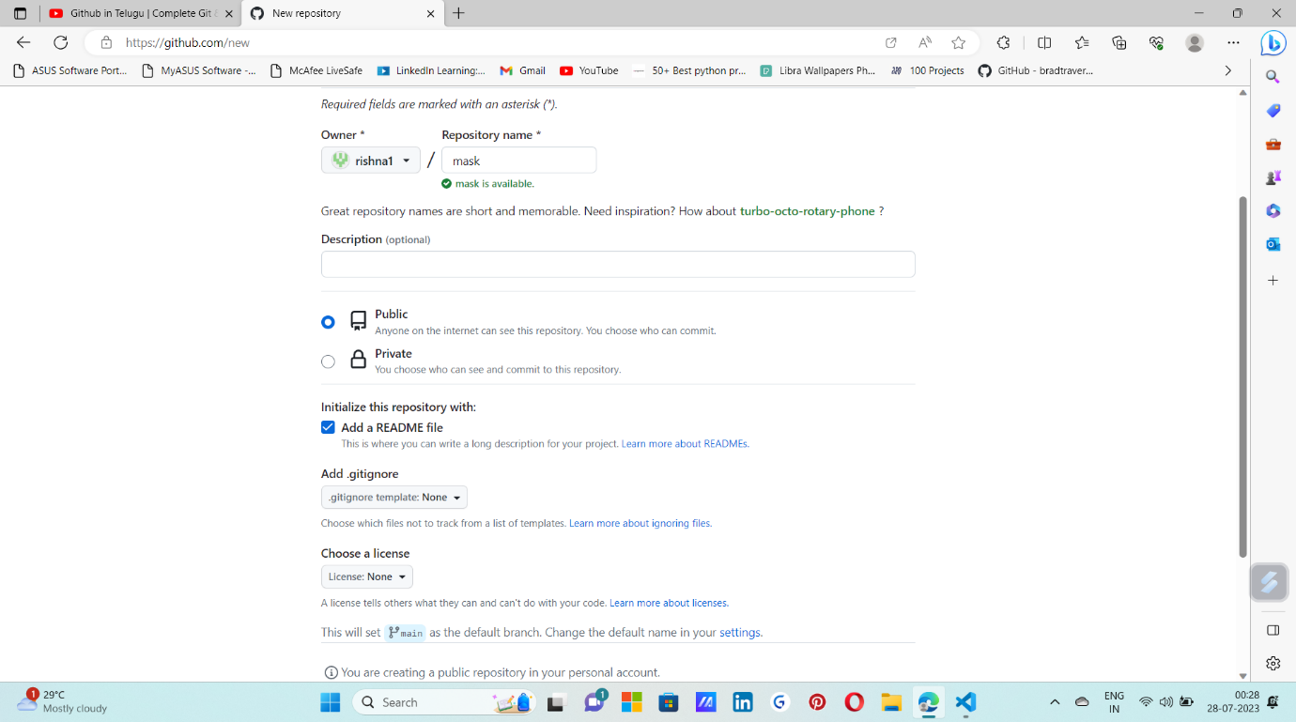

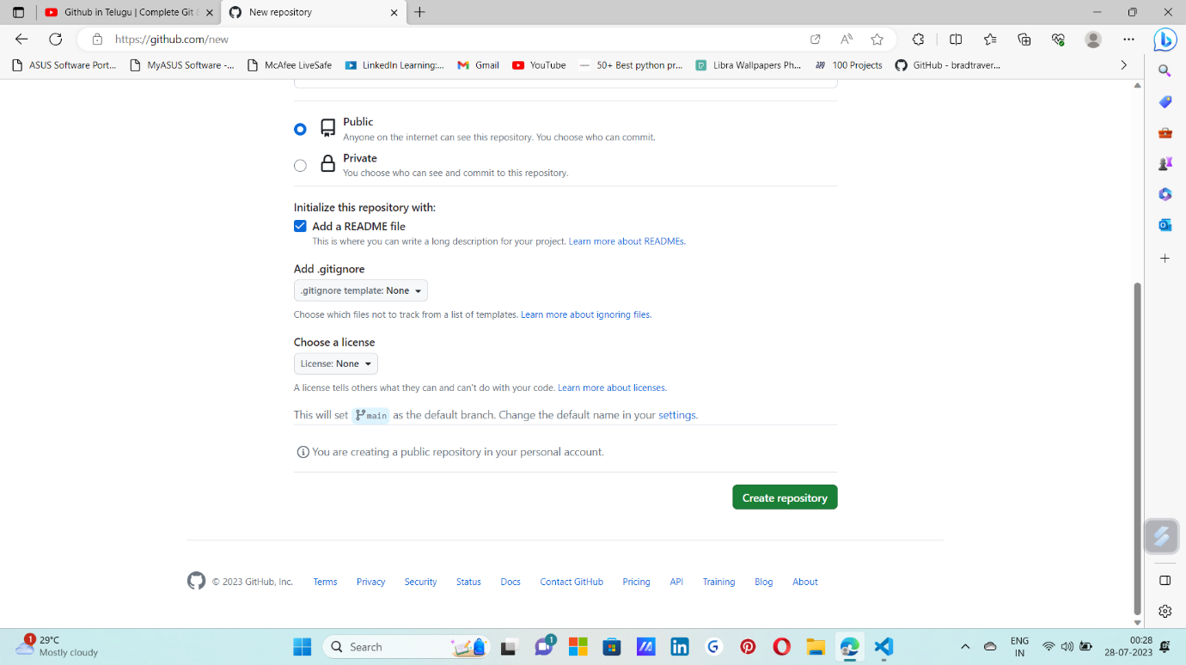

Step 2: enter a repository name and give access public and create repository

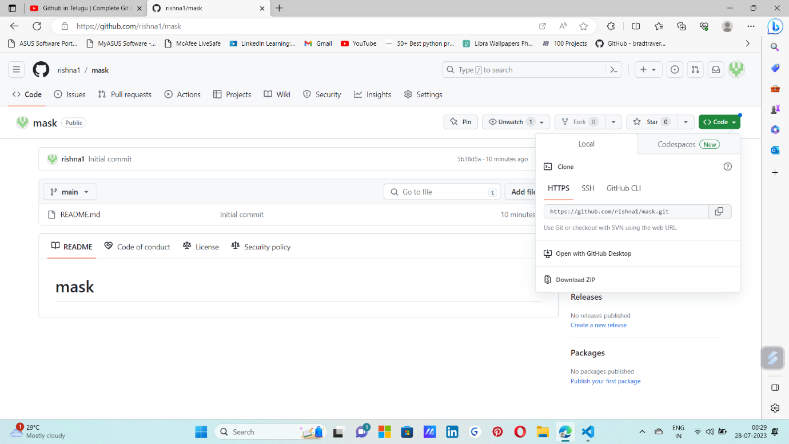

Step 3: click on “code” on the top right corner and copy the https :link

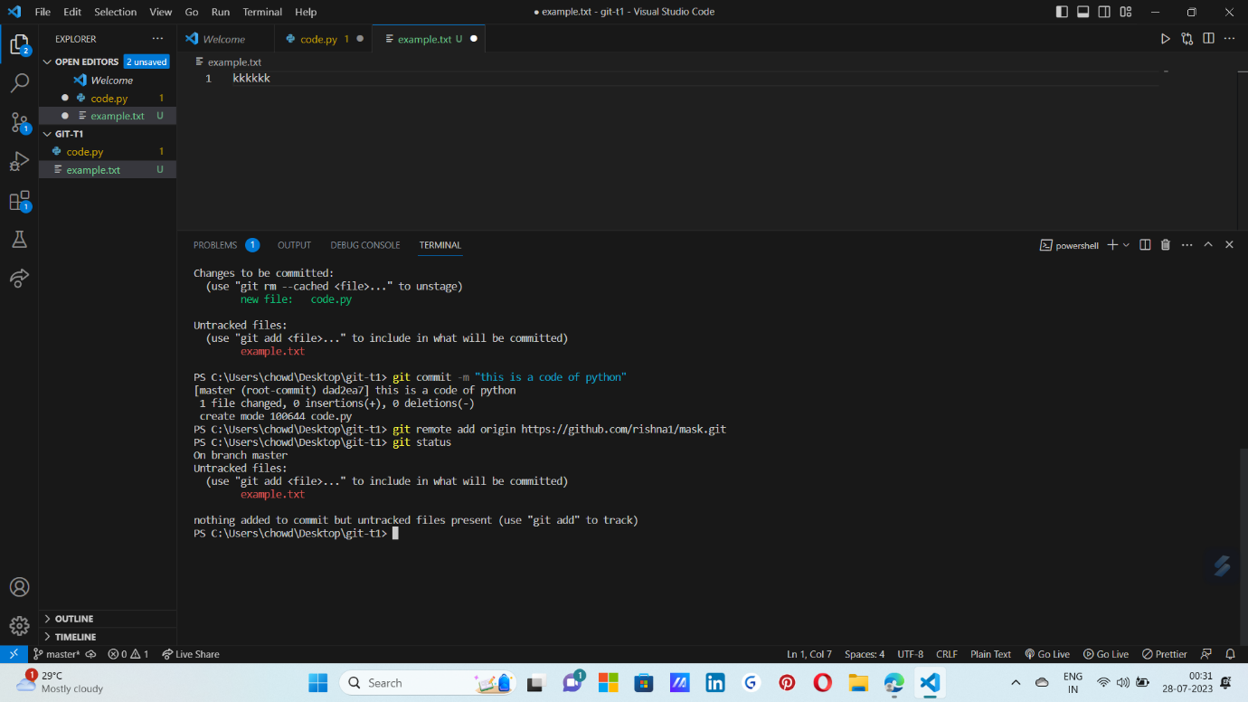

Step 4: enter the copied link in terminal of vs code and check status

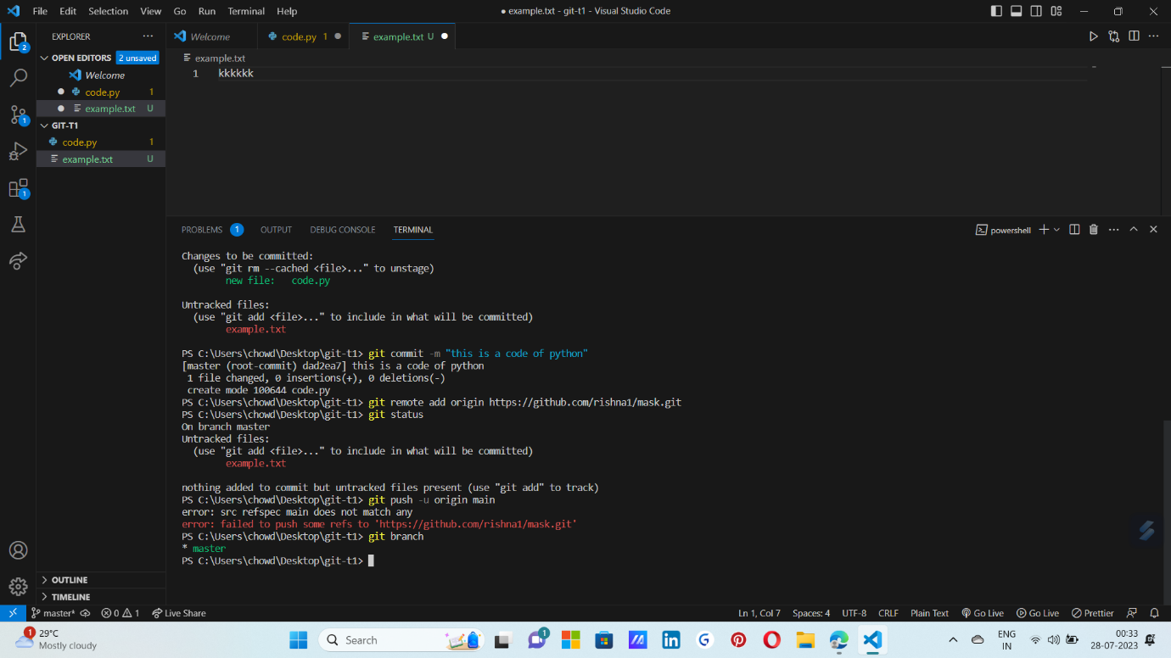

Step 5 : to check which branch we are in use the command (git branch) and use the command (git push -u origin “ master/main”) to push the files

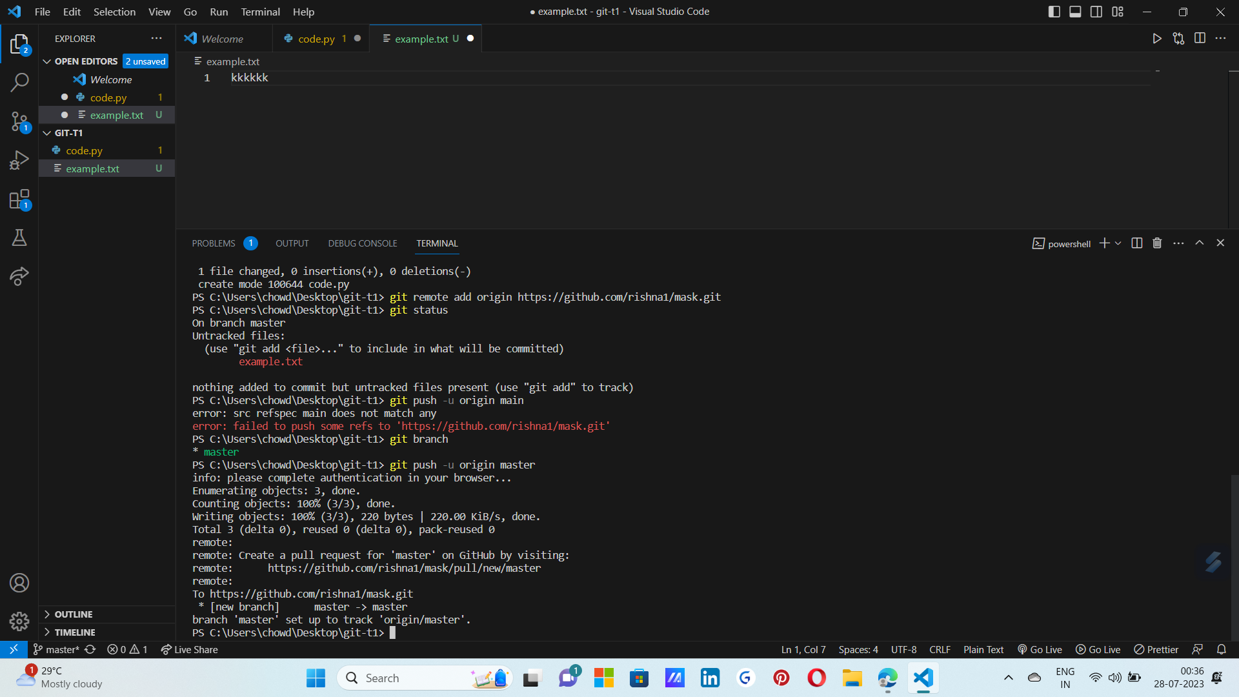

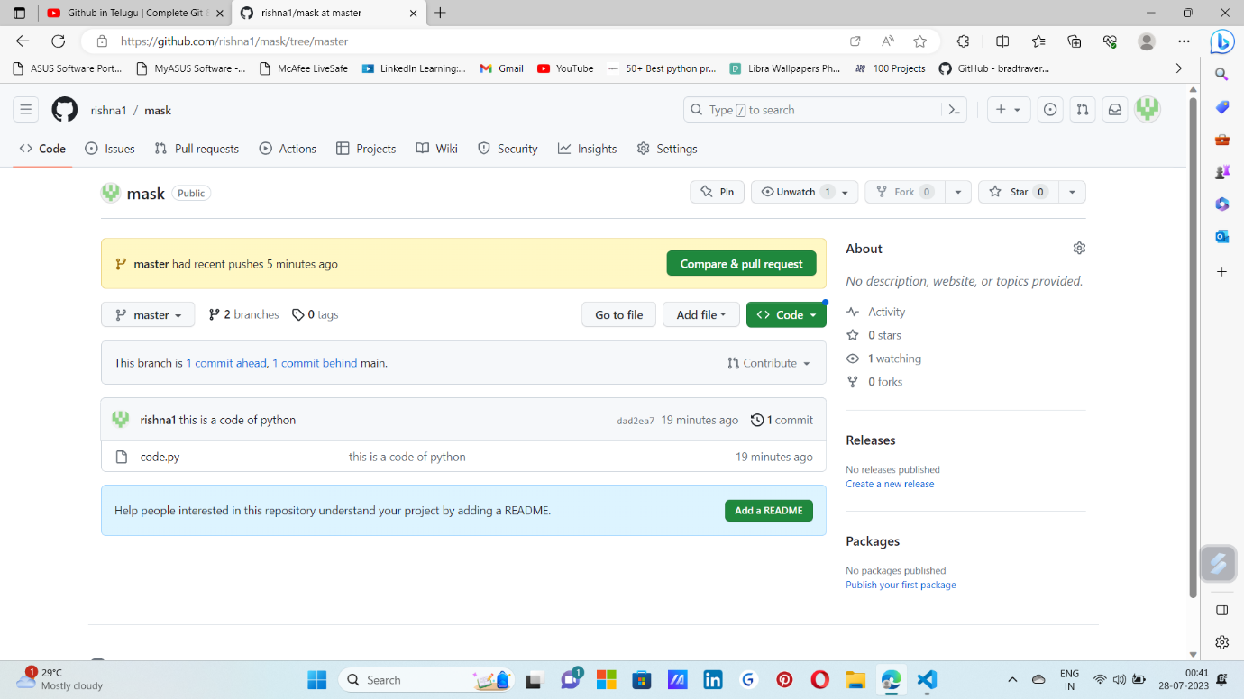

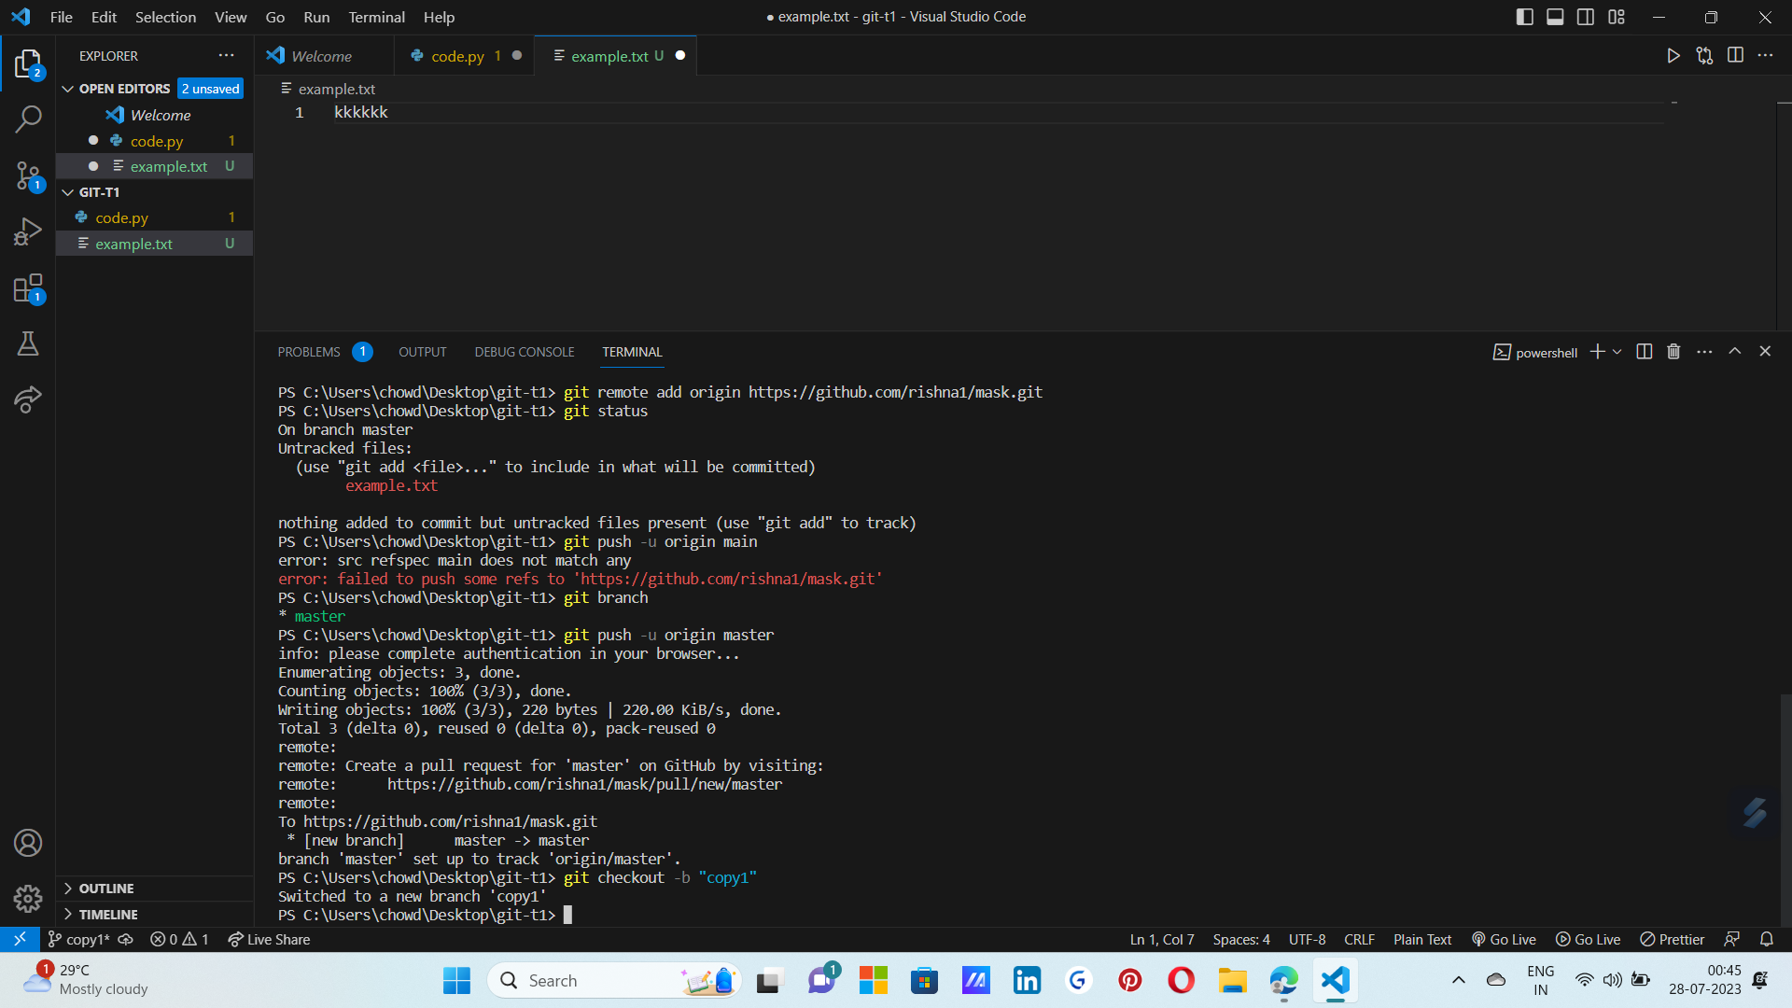

Step 6 : enter the command (git checkout -b “where you want to send”) to send to the directory the file sended to the branch(copy1)

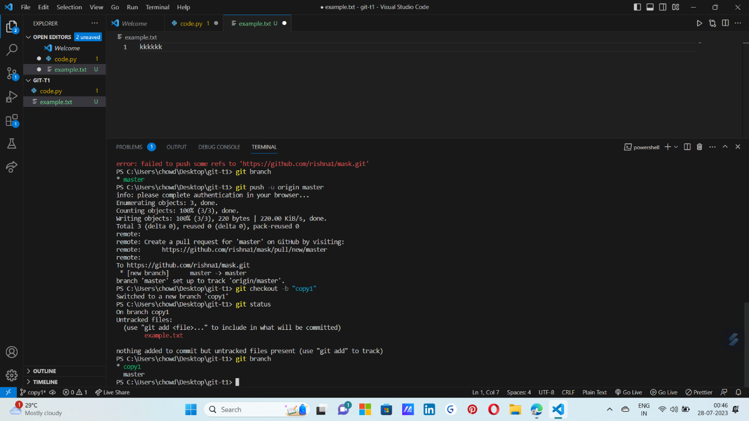

Step 7 : enter command ( git add “file name”) to to add file to repository and chect status by command (“ git status”)

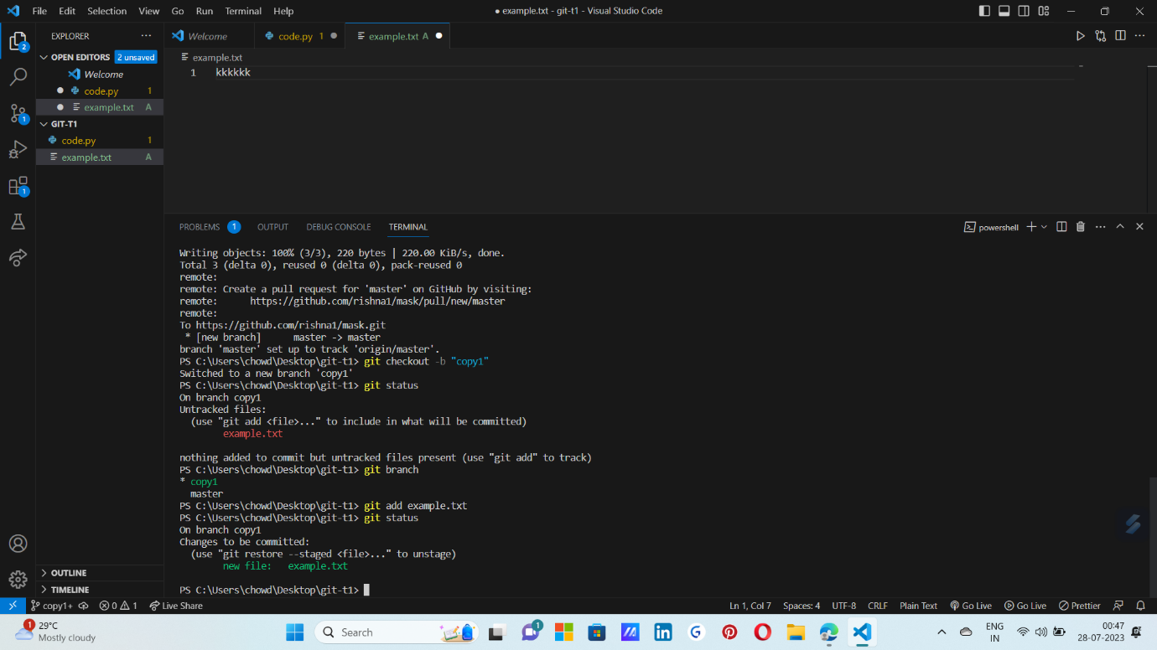

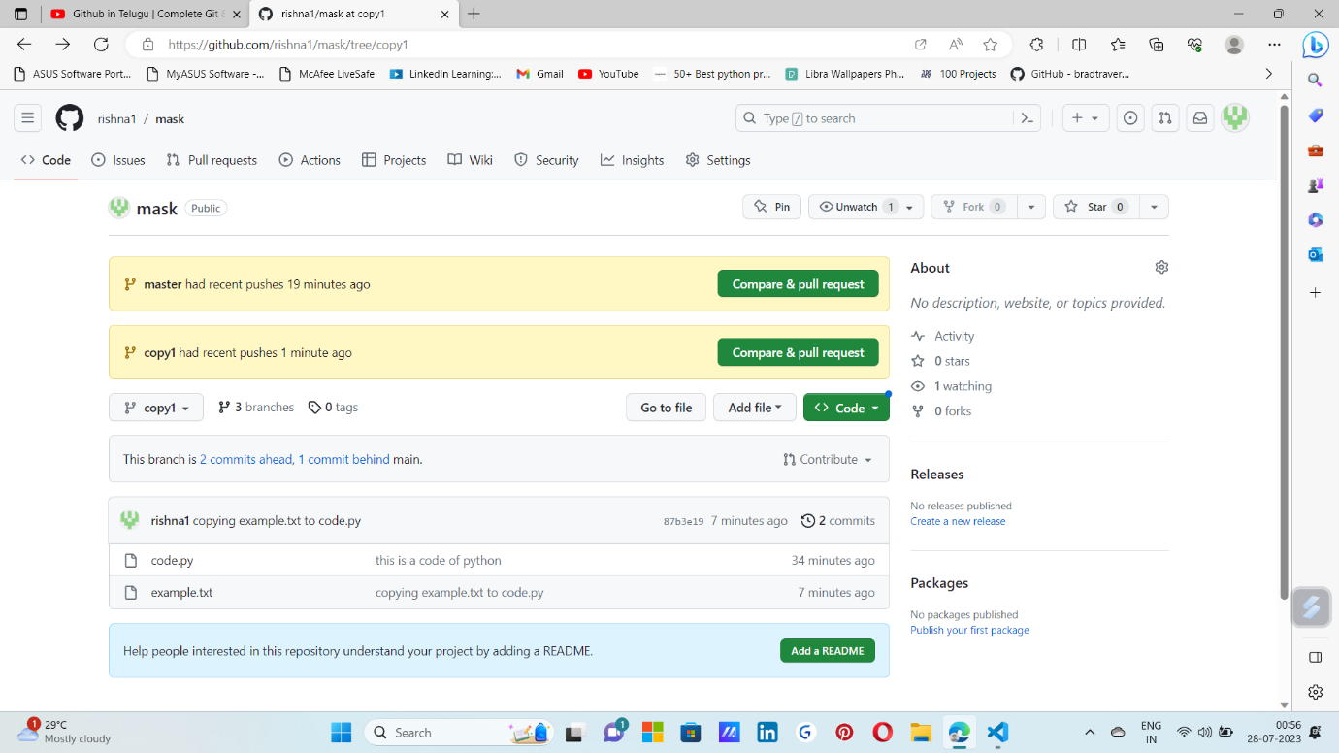

we can see here the branch called copy1 is added and the both files are copied (code.py,example.txt)

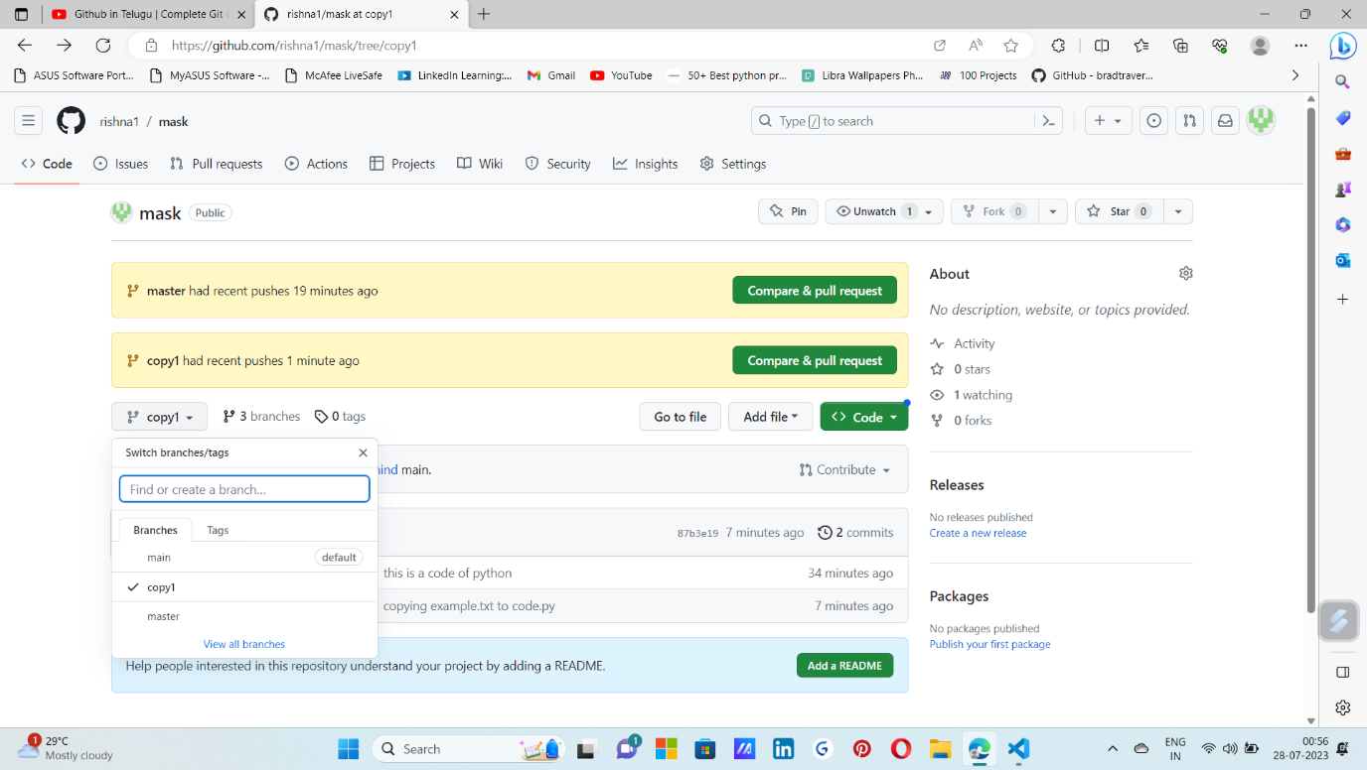 we can see the branches created in the repository